Code No: IT14212
CHAITANYA BHARATHI INSTITUTE OF TECHNOLOGY (Autonomous)
BE (IT) II Yr I Sem (Main) Examination Dec 2014/Jan 2015
DATA STRUCTURES
Time: 3 Hours Max Marks:75
Note: Answer all questions from Section-A at one place in the same order
Answer any five questions from Section-B
SECTION - A (25 Marks)
1. Explain with an example Queue ADT. (2)
2. State the applications of List. (2)
3. What is a Binary Heap? (2)
4. What are the problems in circularly linked lists. How they are resolved (2)
5. Define Tries. Explain various types of tries. (3)
6. What is Splay tree and AVL tree? State the properties of both (3)
7. Compare time complexities of Bubble sort and Quick Sort (2)
8. What are different types of hash functions (3)
9. What is meant by performance analysis? How do you measure an Algorithm performance. (3)
10. Write pre-order, in-order, post-order for the following tree (3)
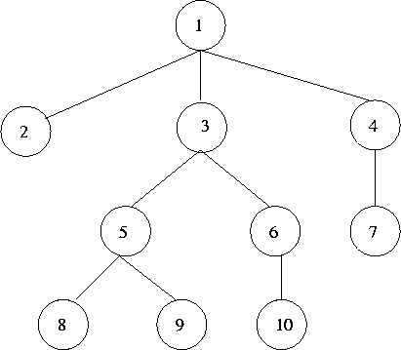

PTO
::2::
Code No: IT14212
SECTION-B (50 Marks)
11.(a) Explain and implement insertion and deletion of a node in a double linked list. (6)
(b) What is recursion? Comment on the efficiency of recursive procedures. (4)
12.(a) Explain the application of stack for matching parentheses. (4)
(b) Give Deque Abstract Data Type. Implement Deque with a doubly linked list in C++. (6)
13. (a) Discuss how a node could be inserted in a binary tree and Construct the binary (5)
tree for the following traversals:
Pre-order: A B D G H C E I F
In-order: G D H B A E I C F
(b) Write an ADT to find K^{th} element from binary tree and explain with example. (5)
14. (a) What is priority Queue. Implement priority queue using single linked list in C++. (6)
(b) Construct Bottom-Up Heap for following list of numbers (4) 6, 5, 3, 1, 8, 7, 2, 4.
15. What are balanced trees? Explain the following in detail with example (10)
i. Properties of Red-Black trees.
ii. Insertion and deletion operation in Red-Black tree.
iii. Balancing of nodes after insert and delete node in Red-Black tree

16. (a) What is a Graph ADT? Write Pseudo code for graph traversal methods. (4)
(b)Illustrate Kruskal’s algorithm for the following graph and discuss time complexity. (6)
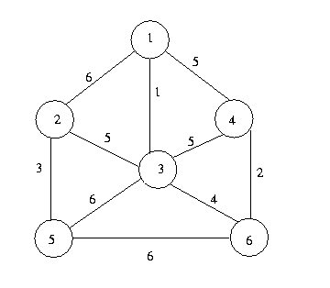
17.(a) Explain briefly about various Collision-Handling schemes. (4)
(b) Write the steps to sort the given list of elements using Radix sort. (6)
459 254 472 534 649 239 432 654 477

